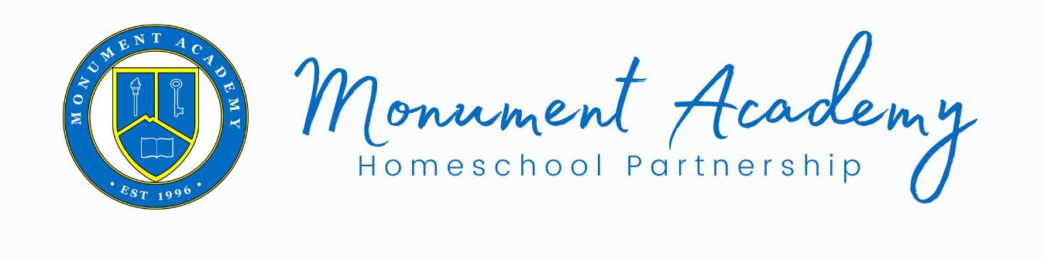
A Day in the Classroom

The Monument Academy Homeschool Partnership is a K-5 program designed to support and partner with homeschool families. Currently, high school grades 9-12 are under consideration and opportunities are being explored for the 2024-25 school year. It is our desire to add 6th grade to the program for the 2025-26 school year. We will continue to add grades until grades K-12 are supported within the Partnership.

For K- 5 students, the day will begin with a warm welcome from the classroom teacher and assistant teacher. Students will engage in a morning opener that discusses the exciting activities for the day, character discussions, birthday or accomplishment celebrations, announcements, and other community building activities. It is our goal that students have fun and engage in positive peer interactions throughout the entire day.

Students will be engaged by a wide variety of activities that include enrichment and academic content, all of which builds on the rich academic content in which the parent provides at home. Students will participate in activities and projects in areas such as music, art, STEAM, physical education, drama, history, reading skills and math foundations. All of the activities and projects are designed and delivered by our licensed, experienced, and highly qualified teacher. The activities may include the items listed below:
- Music: Introductory Instruments, Singing, Music within Cultures, Reproduction of rhythmic and melodic patterns
- Art: Watercolors, Drawing/Sketching, Arts and Crafts, Clay, Sculptures
- STEAM: Makers Space, Team Building Activities, Experiments, Problem Solving
- Physical Education: Team Building, Coordination, Skill Building, Sport Studies, Games
- Drama: Reader’s Theater, Theater Movement, Listening and Speaking
- History: Unit Studies, Role Play/Interviews
- Science: Unit Studies, Labs, Hands-on Activities
- Math and Reading: Opportunities to practice and enhance academic skills through the enrichment activities listed above.

Students will have time dedicated to recess and additional interaction with their peers. Students will have a minimum of two recess periods during the enrichment day. Students will also have a designated snack time.

In addition to the one day a week class, students will be offered additional time on a different day for fun and learning. Various clubs and/or tutoring sessions will be offered based on the interests and needs of the students, activities and/or tutoring will be scheduled on this optional day.

Students enrolled in Monument Academy Homeschool Partnership are part of the One MA family. Students are welcome and encouraged to participate in activities that are open to all students. Activities may include:
- Assemblies
- Core Knowledge Days
- School Library Visits
- Trunk or Treat
- Field Day
- Talent Show
- Spirit Events
- Guest Speakers
- Community Events
- Sports
- Clubs
- And More!

Please visit the Monument Academy website for more information.
www.monumentacademy.net

Questions? Contact Program Manager, Janyse Skalla
jskalla@monumentacademy.net

